Traversing DOM Elements using jQuery

* The jQuery library includes various methods to traverse DOM elements in a DOM hierarchy.

jQuery methods for traversing DOM elements.

| jQuery Methods | Description |
| --- | --- |
| children() | Get all the child elements of the specified element(s) |
| each() | Iterate over specified elements and execute specified call back function for each element. |
| find() | Get all the specified child elements of each specified element(s). |
| first() | Get the first occurrence of the specified element. |
| next() | Get the immediately following sibling of the specified element. |
| parent() | Get the parent of the specified element(s). |
| prev() | Get the immediately preceding sibling of the specified element. |
| siblings() | Get the siblings of each specified element(s) |

**jQuery traversing methods get DOM elements**.

[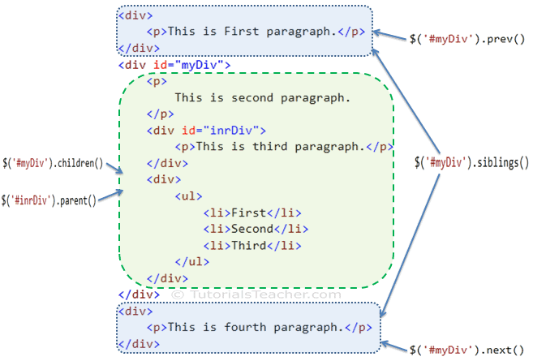](https://www.tutorialsteacher.com/Content/images/jquery/jq-traversing-methods.png)

## **jQuery each() Method**

The jQuery each() method iterates over each specified element (specified using selector) and executes callback function for each element.

**Syntax:**

**$('selector expression').each(callback function);**

Example: jQuery each() method

$('p').each(function (index) {

alert('index' + index + ', text: ' + $(this).text());

});

<div>

<p>This is First paragraph.</p>

</div>

<div id="myDiv">

<p>This is second paragraph.</p>

<div id="inrDiv">

<p>This is third paragraph.</p>

</div>

<div>

<ul>

<li>First</li>

<li>Second</li>

<li>Third</li>

</ul>

</div>

</div>

<div>

<p>This is fourth paragraph.</p>

</div>

## **jQuery children() Method**

The jQuery children() method get the child element of each element specified using selector expression.

Syntax:

$('selector expression').children();

Example: jQuery children() method

$('#myDiv').children().each(function (index) {

alert('Index: ' + index + ', html: ' + $(this).html());

});

<div>

<p>This is First paragraph.</p>

</div>

<div id="myDiv">

<p>

This is second paragraph.

</p>

<div id="inrDiv">

<p>This is third paragraph.</p>

</div>

<div>

<ul>

<li>First</li>

<li>Second</li>

<li>Third</li>

</ul>

</div>

</div>

<div>

<p>This is fourth paragraph.</p>

</div>

## **jQuery find() Method**

The jQuery find() method returns all the matching child elements of specified element(s)

**Syntax:**

**$('selector expression').find('selector expression to find child elements');**

Example: jQuery find() method

$('#myDiv').find('p').each(function(index){

alert('index' + index + ', text: ' + $(this).text());

});

<div>

<p>This is First paragraph.</p>

</div>

<div id="myDiv">

<p>

This is second paragraph.

</p>

<div id="inrDiv">

<p>This is third paragraph.</p>

</div>

<div>

<ul>

<li>First</li>

<li>Second</li>

<li>Third</li>

</ul>

</div>

</div>

<div>

<p>This is fourth paragraph.</p>

</div>

## **jQuery next() Method**

The jQuery next() method gets the immediately following sibling of the specified element.

**Syntax:**

**$('selector expression').next();**

Example: jQuery next() method

alert('Next element to #myDiv: ' + $('#myDiv').next().html());

alert('Next element to #inrDiv: ' + $('#inrDiv').next().html());

<div>

<p>This is First paragraph.</p>

</div>

<div id="myDiv">

<p>This is second paragraph.</p>

<div id="inrDiv">

<p>This is third paragraph.</p>

</div>

<div>

<ul>

<li>First</li>

<li>Second</li>

<li>Third</li>

</ul>

</div>

</div>

<div>

<p>This is fourth paragraph.</p>

</div>

## **jQuery parent() Method**

The jQuery parent() method gets the immediate parent element of the specified element.

**Syntax:**

**$('selector expression').parent();**

**Example: jQuery parent() method**

alert('Parent element of #inrDiv: ' + $('#inrDiv').parent().html());

<div>

<p>This is First paragraph.</p>

</div>

<div id="myDiv">

<p>

This is second paragraph.

</p>

<div id="inrDiv">

<p>This is third paragraph.</p>

</div>

<div>

<ul>

<li>First</li>

<li>Second</li>

<li>Third</li>

</ul>

</div>

</div>

<div>

<p>This is fourth paragraph.</p>

</div>

## **jQuery siblings() Method**

The jQuery siblings()method gets all siblings of the specified DOM element(s).

**Syntax:**

**$('selector expression').siblings();**

Example: jQuery siblings() method

$('#myDiv').siblings().css({"color": "green", "border": "2px solid green"});

<div>

<p>This is First paragraph.</p>

</div>

<div id="myDiv">

<p>

This is myDiv.

</div>

<div>

<p>This is second paragraph.</p>

</div>